Lab Report – 3

1 Bit ALU­­­­

Moida Praneeth Jain (2022101093, Group 4, Table 16)

**Objective**

* To design, implement and test a programmable Arithmetic and Logic Unit to perform 0, OR, AND, EXOR, PLUS, MINUS operations.

**Electronic Components Required**

* Power Supply
* Breadboard
* LEDs
* Resistors
* Wires
* IC 74157 (Quad 2 Input Multiplexer)
* IC 74151 (8 Input Multiplexer)
* IC 7486 (Quad XOR Gate)
* Arduino UNO

**The Reference Circuit**

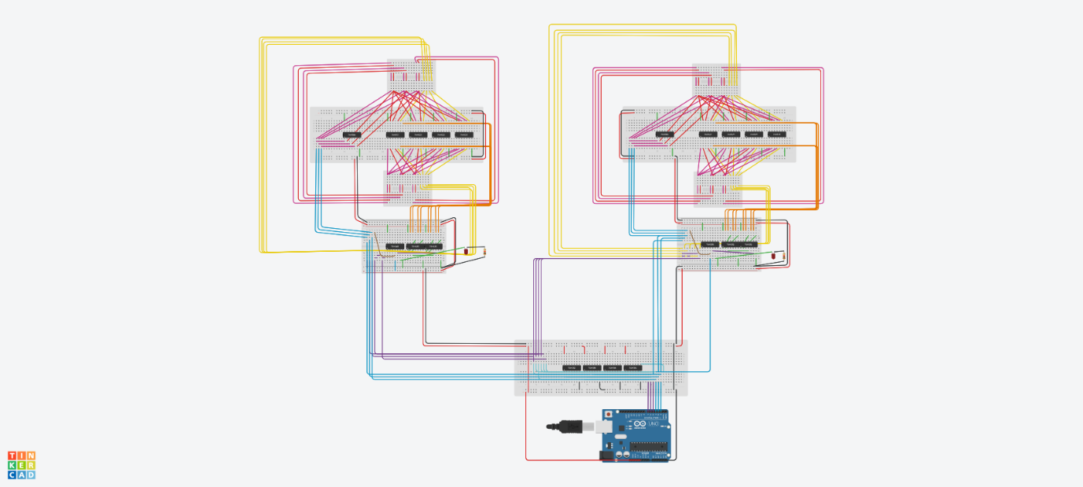

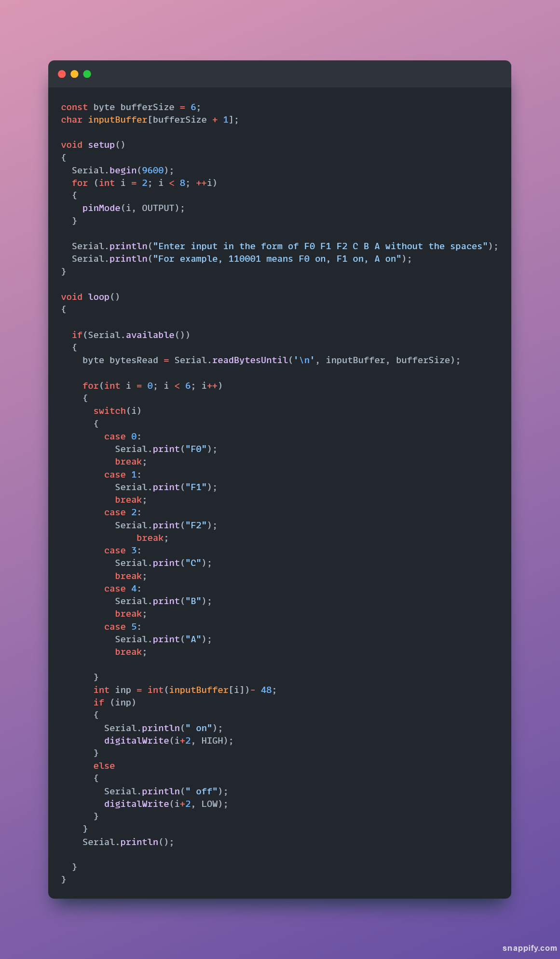

**Procedure**

* Connect VCC and GND from the Arduino to the breadboard.
* Connect the power and ground pins of each of the ICs to VCC and GND using red and black wires respectively.
* Using 2 input multiplexers, with A as select line, get A.B, A’.B, A+B, A’+B.
* Using XOR IC, get A ⊕ B and A ⊕ B ⊕ C.
* Connect the inputs of the MUXs as follows:

|  |  |  |
| --- | --- | --- |
| **Pin** | **Y0** | **Y1** |
| X0 | 0 | A.B |
| X1 | A+B | A.B |
| X2 | A.B | A’.B |
| X3 | A ⊕ B | A’.B |
| X4 | A ⊕ B | A.B |
| X5 | A ⊕ B | A+B |
| X6 | A ⊕ B ⊕ C | A’.B |
| X7 | A ⊕ B ⊕ C | A’+B |

* Set the select lines of Y0 Mux to S0 = F0, S1 = F1, S2 = F2 and EN’ to GND
* Set the select lines of Y1 Mux to S0 = C, S1 = F0, S2 = F1 and EN’ to F2’.
* Connect the outputs of the MUXs to LEDs’ anode and connect the LEDs to the ground using a resistor.

**Observation**

|  |  |  |  |
| --- | --- | --- | --- |
| **F2F1F0** | **ALU Function** | **Y1** | **Y0** |
| 000 | 0 | - | 0 |
| 001 | A OR B | - | A+B |
| 010 | A AND B | - | A.B |
| 011 | A EXOR B | - | A⊕B |
| 100 | A PLUS B | Carry | Sum |
| 101 | A MINUS B | Borrow | Difference |
| 110 | A PLUS B PLUS C | Carry | Sum |
| 111 | A MINUS B MINUS C | Borrow | Difference |

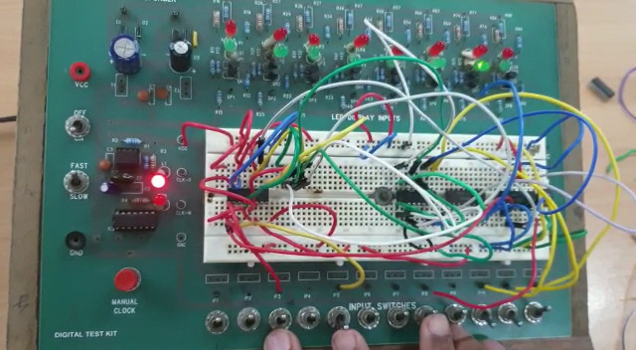

**Conclusion**

* All the operations of the ALU are working as expected.

TinkerCAD simulation link:

<https://www.tinkercad.com/things/7icq46jBN7T-part-4/editel?sharecode=jQZnYruLAobln9N31O9_kqhBsrOCG1nkdEW3CrHaDKY>